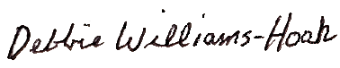

Presented To

~ Name~

Spring 2023

Honorable Mention All-State

Division 2

MIGCA President

Coach